1. Open Flipkart.com in Chrome, right-click on the search box, and use Inspect Element to find and write down its id, name, and CSS selector.
- Ans=> Open Flipkart.com in Chrome.
- Right-click the “Search for Products, Brands and More” box.
- Select Inspect.
- In Elements, the highlighted <input> element will show attributes such as:
  - id="..."
  - name="..."
  - class="..."
- For the CSS selector, right-click the highlighted element → Copy → Copy selector.
Important: Flipkart changes its DOM attributes periodically, so I don't want to give you an outdated id/name and present it as the result of your current Inspect session.
If you paste the highlighted <input ...> line here (or upload a screenshot), I can immediately give you the exact ID, name, and CSS selector.

2. On the Zomato homepage, use Chrome DevTools to extract the XPath for the 'Log in' link and explain whether this locator is likely to be stable or fragile.<br><br><em><strong>Hint:</strong> Consider if the XPath depends on position or text that might change.</em>
Ans=> This XPath is reasonably stable but not guaranteed.
- Good: It identifies the link by its visible text rather than its position, such as /html/body/.../a[2].
- Potentially fragile: If Zomato changes the wording from “Log in” to something like “Sign in”, the XPath will stop matching.
- Very fragile alternative: An XPath based on absolute position, e.g. /html/body/div[1]/..., can break whenever the page structure changes.
Best practice: Prefer a unique, semantic attribute such as id, data-*, or an accessible attribute if DevTools shows one. Text-based XPath is preferable to positional XPath when no stable attribute is available.

3. Choose any visible button on the BookMyShow homepage and use Chrome DevTools to extract both its CSS selector and XPath. Paste both locators and briefly describe which one you think is more reliable for automation.
- Ans=> button[aria-label="Sign in"] directly targets a meaningful attribute.
- It doesn't depend on the button's position in the page.
- It is concise and typically performs well in Selenium.
- The XPath version is also good, but becomes fragile if it relies on text, indexes, or the page's DOM hierarchy.

4. Using Selenium IDE, record a simple test on Myntra.com that clicks the 'Men' menu link. After recording, view the test step and note which locator type Selenium IDE picked for the 'Men' link (id, name, linkText, CSS, or XPath).
Ans=> 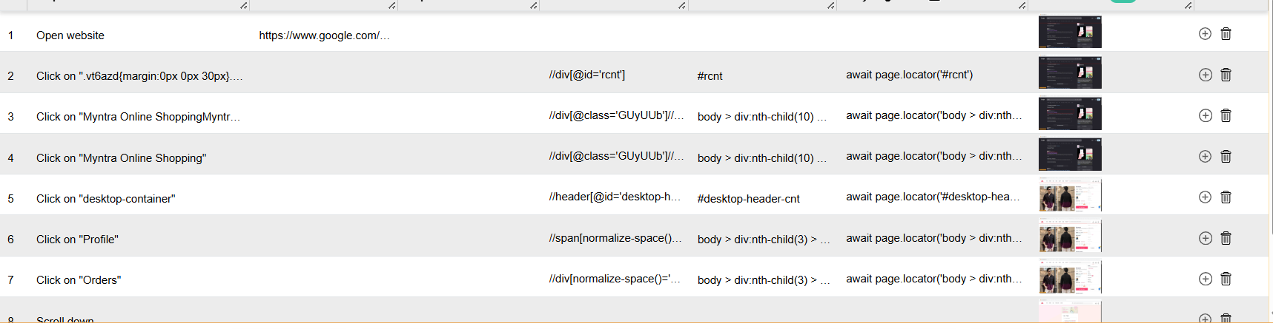

5. Pick a product listing element (like a product card) on Amazon.in and suggest a custom CSS selector that would remain stable even if the site's layout changes slightly. Justify your selector choice.<br><br><em><strong>Hint:</strong> Avoid selectors based only on index or class names that look auto-generated.</em>
Ans=> ChatGPT said:
For an Amazon.in product card, I’d prefer a selector based on a semantic/stable attribute rather than the card’s position or CSS classes.
A good example is:
div[data-component-type="s-search-result"]
- emantic attribute: data-component-type identifies the element's functional role as a search result.
- Not position-dependent: It doesn't rely on div:nth-child(...), so inserting or removing products shouldn't break it.
- Less dependent on styling: Unlike selectors based on classes such as .s-result-item, it isn't tied primarily to presentation.
div[data-component-type="s-search-result"][data-asin] is preferable to something like div:nth-child(3) or a long XPath containing multiple nested <div> elements. Amazon can change its DOM, so no selector can be guaranteed permanently stable.

